## Tank Tables

### General,

Each ship must have some kind of device to show the content of the divers tanks. Whether it is a glass tube, a pressure sensor, a capacitive sensor or a float unit, they are all designed to show the contents of the particular tank. While the first is a mechanical device, the rest is merely electrical.

The bigger ships will rely more on an accurate reading. Not only will they travel over longer distances, or need to be cost effective, they also often need to balance the ship by even things out in diverse ballast tanks. You can understand that the calibration of these sensors will have to be quite accurate.

### types of sensors

We will focus here on the electrical sensors as the mechanical ones gets more and more obsolete. The most used ones are

* The floating sensor
* The capacitive sensor
* The pressure sensor

#### Floating sensor

The floating sensor can be compared with the float unit that is used in toilets. These type of sensors are level-sensors. They measure how high (or low) the level of the fluid in the tank is. They can be equipped with a floating device connected to a hinged part, where the hinged part is electrically connected to a resistor which will give a voltage or milli-amperage that can be used to show the actual level of the liquid. The floating device can also be a magnetic ring attached around a pipe. For calibrating this device, please refer to Chapter 2.9.6.

#### Capacitive sensor

The principle of capacitive level measurement is based on change of capacitance. An insulated electrode acts as one plate of capacitor and the tank wall (or reference electrode in a non-metallic vessel) acts as the other plate. The capacitance depends on the fluid level. An empty tank has a lower capacitance while a filled tank has a higher capacitance. While this is also a level measuring type it can be calibrated as told in Chapter 2.9.6.

#### Pressure sensor

The pressure sensor is not a level indicator. It measures the liquid pressure (Pl) of the column of liquid above the sensor. In conjunction with the density of the liquid you can calculate the volume of the liquid. When the architect of the tanks has provided a sounding table, with the liquid pressure you can calculate the height of the liquid as well as the m3 of liquid. Again with the density you can calculate the mass (tonnage). You can see that this provides a very accurate and diverse scheme for the tanks that is very useful.

Within the FT NavVision © system all this calculations are done automatically once you provided one of the variables. (see Figure 2‑45)

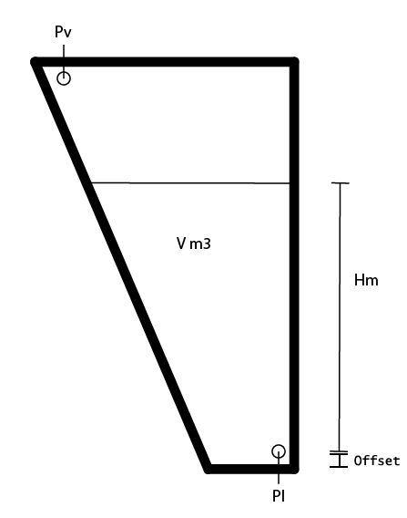

Figure 2‑45: Tank Pressure Sensor

|  |  |
| --- | --- |
| **Abrreviation** | **Explanation** |
| Pl | Liquid Pressure |
| Pv | Vent Pressure |
| V m3 | Volume in square meter |
| Hm | Height in meter |
| Offset | Offset sensor in meter |

Table 2‑3: Pressure sensor explanation

*: When not provided with a Pressure Vent Sensor it might give some strange irregularities. Especially when the vent-pipe is too small it will interfere with a good reading of the pressure sensor, while the air above the liquid column will be shifting all the time. It might then be necessary to place a Vent Pressure Sensor to even this out. Also this calculation is done automatically within FT NavVision ©.*

### Calculations

Just for your understanding we will put down the calculations we make in NavVision.

Depending on which value you have, we distinct the following calculations:

$$H = \frac{Pc*100}{g*D}$$

$$Pc = \frac{H*g*D}{100}$$

Pc = Pl – Pv (mBar)

g = 9.80665 (m/s2)

D = Density (kg/m3)

|  |  |
| --- | --- |
| **Abrreviation** | **Explanation** |
| H | Height |
| Pc | Pressure column |
| g | Average gravity |
| D | Density |
| Offset | Offset sensor in meter |

### Offset

Every sensor will have an offset. None of the sensors will be exactly on the bottom of the tank. Especially when the tank expands upwards, a small offset can make a big difference when the tank is full.

When you know the offset of the sensor you can adjust this in the tune table of that particular tank. Goto Fieldsettings/tune and look for the tank that you are about to adjust. Make sure you use the “Height” value. See the following figure:

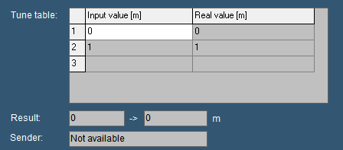

Figure 2‑46: Tune table

Now let’s say that your sensor has an offset of 20cm. This means that if the sensor reads 1 meter of height it is actually 1.2 meter.

You can adjust that by changing the input value and the real value accordingly. So now we know that if the sensor has an input value of 0m it is actually 0.2m and if the sensor has an input value of 1m it is actually 1.2m

If you change that in the tune table (see Figure 2‑47) NavVision will calculate with the right values.

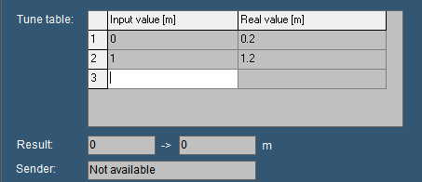

Figure 2‑47: adjusted tune table

### Inserting sounding tables

Under Configuration>Tank Tables you can find all the tanks. (see Figure 2‑48).

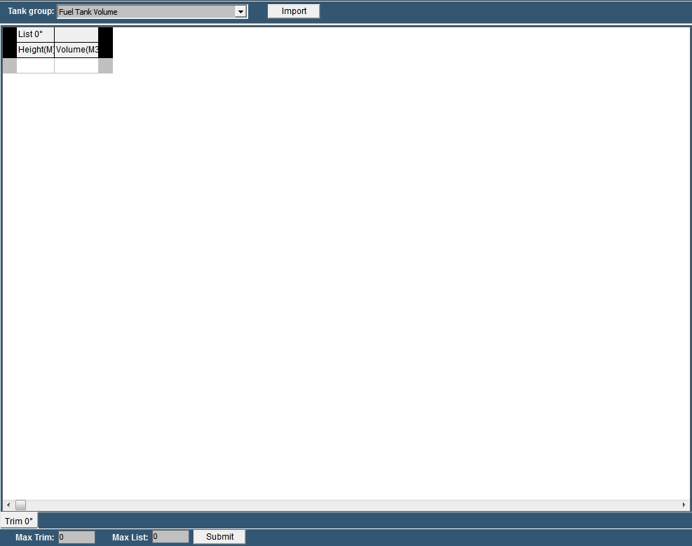

Figure 2‑48: Tank Tables

|  |  |
| --- | --- |
| **Detail** | **Description** |
| Tank Group | Find the tank you want to adjust a tank table for |
| Import | Import an Excel-sheet with sounding data |
| Max Trim | Max pitch (if provided in sounding table) |
| Max List | Max Roll (if provided in sounding table) |
| Submit | Submit Trim and List |

Table 2‑4: Tank Tables

#### Tank Group

In the drop down menu you can search for the tank that you are about to adjust. You will get all the tanks available. In this example we will use the Fuel Tank 1 Volume (see Figure 2‑49).

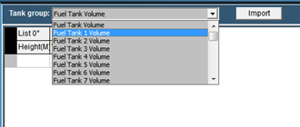

Figure 2‑49: Tank Group Drop Down

You’ll notice it only shows the tank group volumes, as that is what you get in the sounding table. As mentioned earlier with height and volume, FT NavVision © can calculate all the other values.

Now that you have chosen the right tank, you can manually fill in the diverse heights and volumes. Make sure you start with “0” and end with the highest value or your value will be the wrong way around.

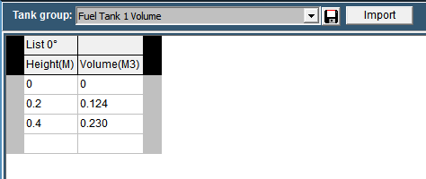

Figure 2‑50: Filling in tank tables

As soon as you start filling in the numbers you will see a “save button” appear next to the drop down menu (see Figure 2‑50). With this button you can save the calibration table to the specific tank. FT NavVision © will immediately start working with this values.

Of course filling in large amounts of data like this will be quite time consuming. Therefor it is possible to import the data from an excel sheet providing the excel sheet is setup the right way.

#### Excel import

Most times the calibration tables or sounding tables will be available in some kind of excel format. It is wise to start with a new excel-sheet where you transfer the data from the sounding tables to, one by one. You can name the different tabs to the “trim” and “list” (see Figure 2‑51).

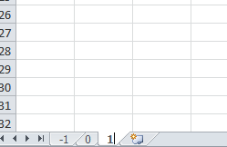

Figure 2‑51: Excel tabs

So for an example list we take the following sounding table:

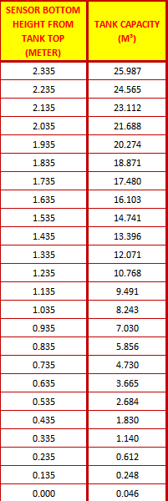

Figure 2‑52: Example Sounding Table

As you can see it goes from high to low, which is the wrong way around, but we change that later. First select all the values and “control-c” to copy the data. Go back to your original excel document and paste it on the SECOND row (see Figure 2‑53).

*: Use Paste Special “values” or “Unicode”*

*: in the first row you need to use an empty cell and the second cell with the “List” degree-number*

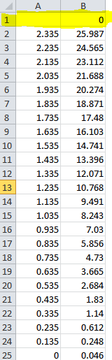

Figure 2‑53: Excel sheet import list

Now select all the values except for the upper row and choose “Sort>from low to high” to get the data in the right order. Once this is done you will have the right values for the list (see Figure 2‑54).

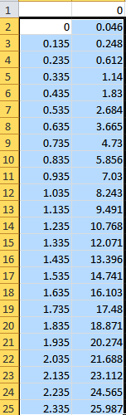

Figure 2‑54: Excel list sorted

Now save the new made table as “Excel97-2003 *.xls”file. In this case we name it “Fuel Tank 1”.

#### Import from excel

Now go back to the “tank tables” and click on “import”. Look for the excel file you just created and choose it for import. Click OK and the list will be imported and shown. (see Figure 2‑55).

At this time you can save the table and it will be used within the calculation of FT NavVision ©.

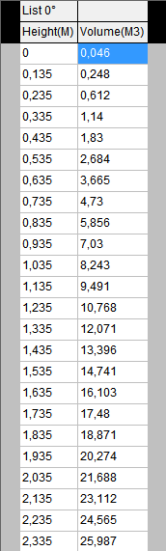

Figure 2‑55: Imported Table

### Trim and List

Ships move in different directions. They can roll over the latitude axis (the roll or list), or over the longitude axis (the pitch or trim). You can imagine that when the ship is moving, the liquids in the tanks will also move. This way the method of measuring with a pressure sensor will have some shortcomings.

For instance, when the ship is rolling over, the liquid column above the pressure sensor can alter. In this example it gets shorter (see Figure 2‑56). This way the calibration will alter. The pressure sensor thinks it has a smaller column of liquid and will refer to the calibration table. While the tank is abating here, there will be much more liquid available than the calibration table will say.

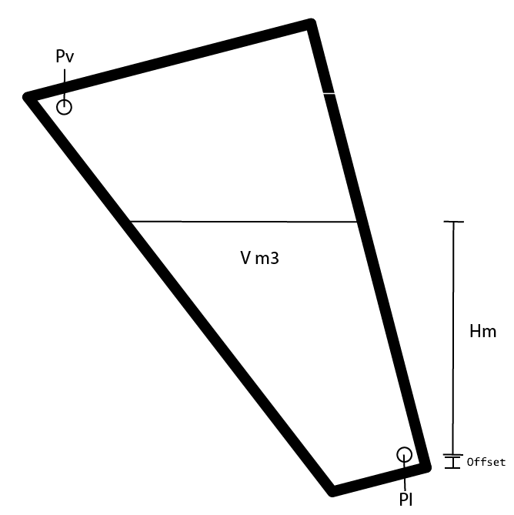

Figure 2‑56: Roll and Pitch

When an architect kept that in mind he surely will have the calibration or sounding table recalculated in different roll and pitch positions. This way you can make an even more accurate calibration.

#### Roll and Pitch in the Tank Table

In the tank table page you will find two “edit fields”. One for the Trim and one for the List. While Trim is the Pitch of the ship and List is the roll of the ship you can alter the number accordingly to the number of different sounding tables you have. If, let’s say, you have seven Trim Tables, fill in the number “3” and press “submit”. You’ll notice that there are now three tabs on either side of the 0-degree tab. -3,-2,-1,0,1,2 and 3 degree. (see Figure 2‑57). For this you need to have 7 different sounding tables from the architect.

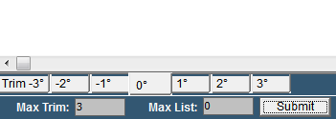

Figure 2‑57: Max Trim

Now let’s say that you have only three sounding tables for the roll (List). Fill in the number “1” and press “submit”. Now you will have three different columns for the sounding tables of the “List” -1,0 and 1 degree (see Figure 2‑58).

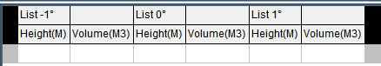

Figure 2‑58: Max List

This way you’ll have 3 different “list” columns for 7 different “trim” tabs so 21 different calibration points (see Figure 2‑59). In this ideal configuration you will have a very accurate calibration.

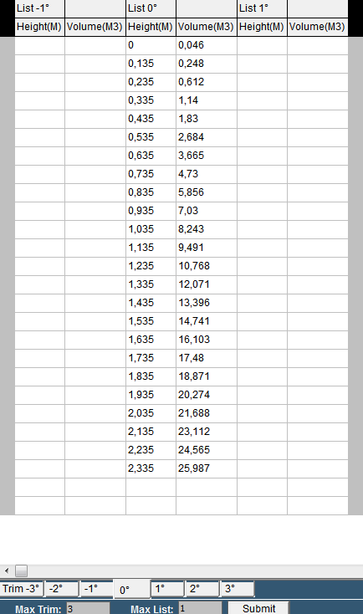

Figure 2‑59: Trim/List example

#### Trim and list in Excel

When you are importing sounding tables through an Excel list you would like to put in the trim and list at the same time. This is possible by doing the following:

Taken the previous as example you will have to make 7 tabs and rename them according to the degrees in the sounding table. For the trim you will make a column for each degree that you have in the sounding table and rename these in the upper row right cell of each separate column (see Figure 2‑60).

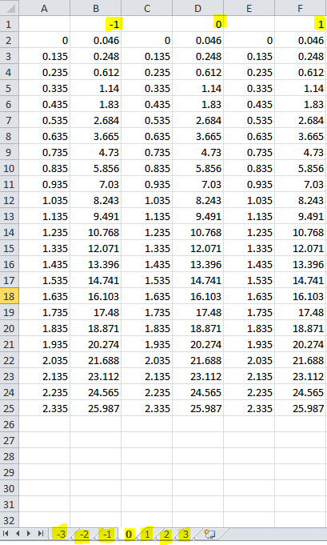

Figure 2‑60: trim and list excel example

Now save the excel sheet, import it in the tank table page, save it and you will have all the data ready to be used by FT NavVision © (see Figure 2‑61)

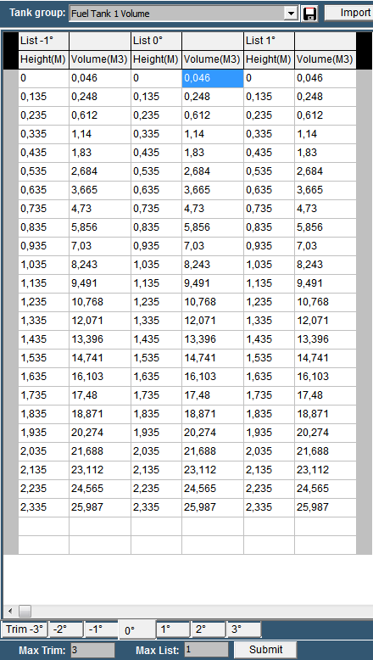

Figure 2‑61: Tank Table excel Trim and List import

*:Max Trim and Max List is 20 degrees*